TOTAL AVAILABLE MARKET (mobile ad space)

APP BUILDERS

AppyPie

[Mobi-cart](http://mobi-cart)

Others

Advertising platforms

Google’s Admob

MARKET TRENDS (WHAT ARE THE OTHER GUYS DOING)

HOW ARE WE DIFFERENT

OUR ASSUMPTIONS

* Users more likely to buy products curated by developers than products served by ads
* Users are more likely to buy if they stay in app for purchase
* Developers will make more per user than ad revenue because of a larger profit share
* Retailers will give up 30% profit share to capture a larger market

## 

## COMPETITIVE LANDSCAPE W/ AD REVENUE OPTIONS

## diagram.png

## MOBILE AD REVENUE

* Typical $10k/yr per 100,000 active users
  + $ 0.0002739726 per user-day
* What metric do we want to use to compare ourselves to ad revenue?
  + $ / active user / day?

## 

## Competition

### App builders

#### Appypie

<http://www.appypie.com/>

* DYI mobile app builder - generic to any type of app
* Drag and drop app builder
* Hosting provided by Appypie
* Analytics
* App listed on Appypie marketplace
* Customer support
* Push notification setup
* Free mobile website with custom domain
* Supports web, ios, android
* One-time free app submission
* 30 days money back guarantee for first app
* Does not cover $99 app store yearly charge or the $25 Google play one-time charge
* Funding, crunchbase reports only a $10K crowdfunded investment, jesus christ that’s crazy
* <https://www.crunchbase.com/organization/appy-pie>
* It was originally a Game builder funded on kickstarter: <https://www.kickstarter.com/projects/1362913594/993378770/widget/video.html>

**Several pricing plans**

Free:

* Has ads, no other perks

Basic

* Has perks listed above
* 5000 push notifications
* + No ads

Gold

* Above perks
* + 10000 push notifications

White

* Above perks
* + 25000 push notifications
* No AppyPie branding

White

Monthly

* 0-50$ tiers
* Free tier has ads
* More expensive tiers ads additional push notifications
* Most expensive tier removes AppyPie branding from app.

Yearly

* 20% discount
* Same perks

Lifetime

* 50% discount
* Per app cost 0-1500$ one time charge with same perk tiers as above

**Notes**

* This is basically the Myspace of the app building community.
* No polish, everyone has free reign to make crappy apps

Examples of some of their featured apps on their marketplace:

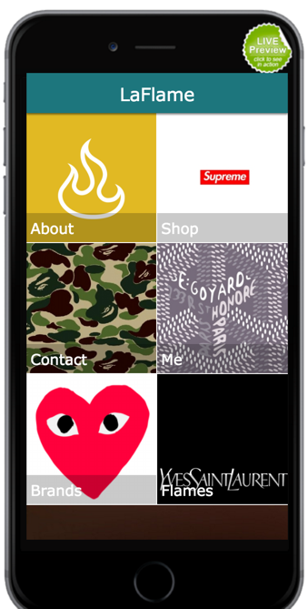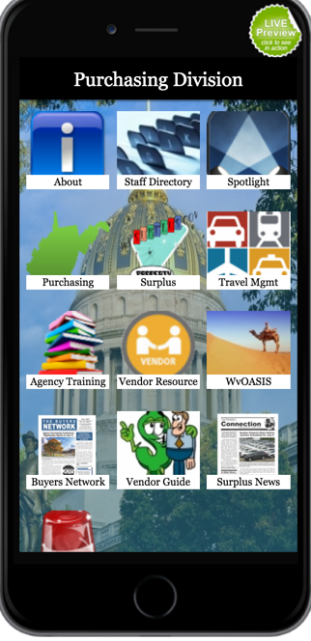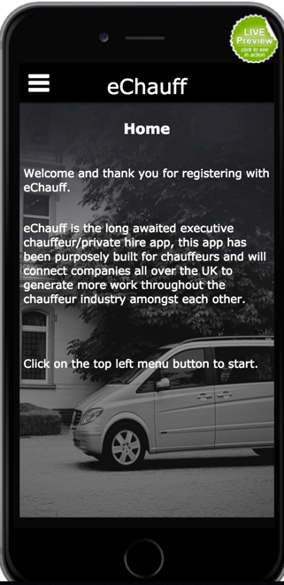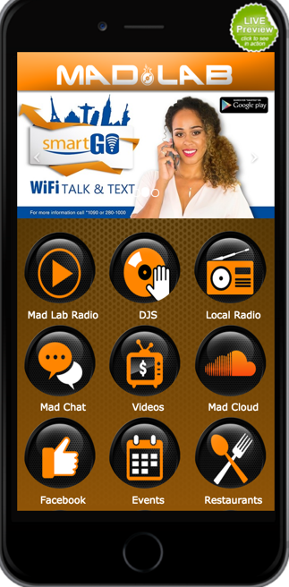

### Mobi-cart

<http://www.mobi-cart.com/>

* Mobile store app builder
* Ecommerce mobile app builder
* This would be a straight competitor, but they’re so terrible I would hardly call it competition
* $1MM in in investments
* <https://www.crunchbase.com/organization/mobicart>
* Built in integration with several POS and ecommerce platforms. Notably Shopify, Joomla, Magento, Opencart, Zen cart
* Native checkout experience: integration with with Paypal, ZooZ and Stripe
* You’re actually buying the app builder not an individual app.
* Does not cover submitting to apple or android (self hosting)

**Pricing plan**

Monthly

* 0-98$
* Low tiers only allow you to build android apps, higher tiers allow you to build ios and web
* The biggest distinction is products you can sell on the app. The free tier allows you to have 10 products listed. The pro tier lets you have 7000, and charges $5/mo for each additional 1000 products.
* Free tier: 10 products, no other perks
* 98$ - pro plan: 7000 products can be built, access to app source code

Examples from their website of features apps:

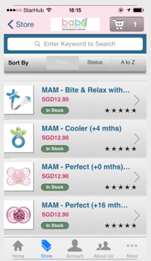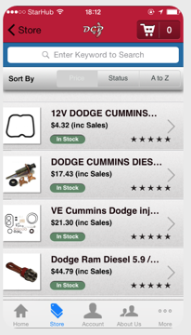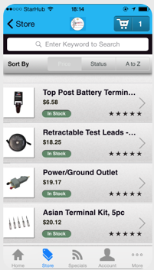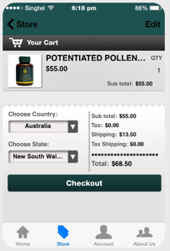

### Others

There are plenty of of other equally terrible companies.

<https://apptuse.com/integration-details/>

## Advertising Platforms

### Google’s Admob

<http://www.google.com/admob/>

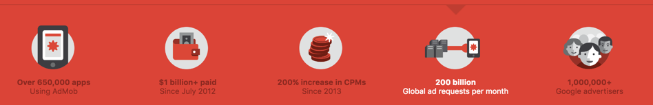

* 650,000 apps
* $1B+ paid since July 2012
* Boost 200% increase in CPMS since 2013
* 200B global ad requests per month
* 1M+ advertisers
* Cross platform
* Integrates with Google Analytics
* Free to use

Examples featured:

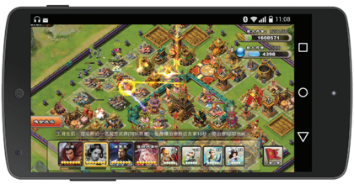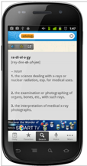

## 

Others

Shopify mobile buy SDK

<https://docs.shopify.com/api/sdks/mobile-buy-sdk>

<https://www.shopify.com/blog/26378820-sell-products-in-your-mobile-app-using-shopify-s-mobile-buy-sdk-and-apple-pay>

* Allows developers to embed products or a store into their apps
  + For example, GoldieBlox is using an early version of the Shopify Mobile Buy SDK to sell their toys in their GoldieBlox and the Movie Machine game.
* Works for embedding your own store into other apps you may own
* Checkout using ApplePay or credit card
* This is very similar to what we want to do, with the exception that they’re limited to the user’s own shopify accounts.
* Shopify experts can build stores/buy buttons for you at a hefty price of $3K+: <https://experts.shopify.com/expertise/mobile-development>

Example

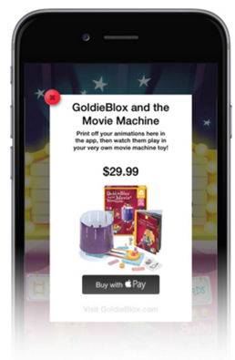

## 

## Market

[Source](https://www.internetretailer.com/2015/08/18/mobile-commerce-now-30-all-us-e-commerce)

* 2015 mcommerce sales total $104 billion
* Mcommerce sales up 38.7% 2014 → 2015
* USA: +38.7% (actually the slowest growth)
* Asia: +249.3%
* Europe: +70.7%
* Latin America: +59.6%

[Source](http://www.emarketer.com/Article/Mobile-Ad-Spend-Top-100-Billion-Worldwide-2016-51-of-Digital-Market/1012299)

* Market size 2016 $100B worldwide
* Market size by 2019 will be $197B worldwide